**LAB # *07***

***Illustrate Sequence Diagram Using “Rational Rose”***

### *Exercise 7.1:*

***Model a Sequence Diagram for login operation***.

• *The new customer will enter his/her user id& password and then click on login button on the login.aspx Webpage.*

*• The Session Manager gets the user id and user details from Customer class instance and verifies the user id and password.*

*• If user details are invalid customer will not be allowed to login and an appropriate error message will be displayed, otherwise the customer is logged in.*

*• Add the People Information, University Artifacts, and Interfaces packages to the Main class diagram.*

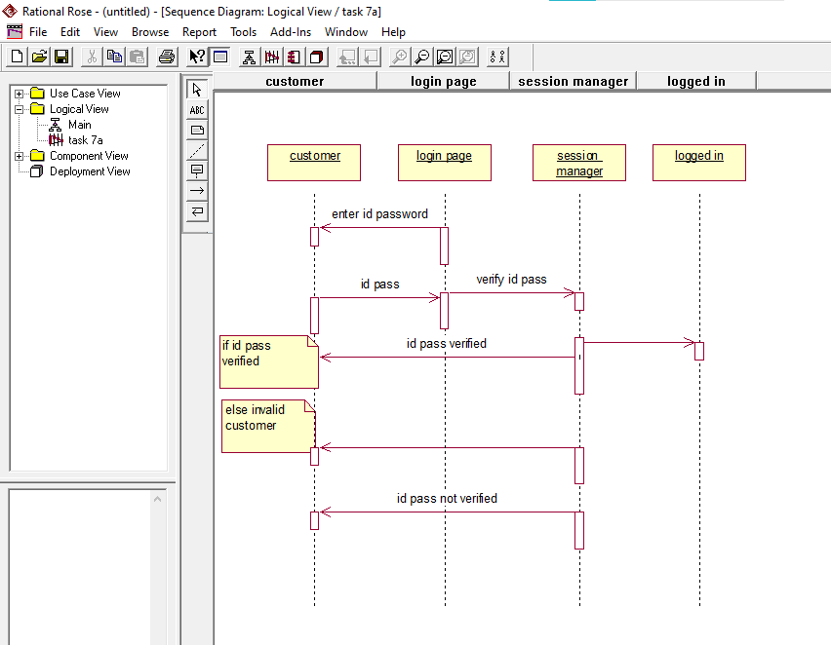

### *Exercise 7.2:*

***Model a Sequence Diagram for the Library Management System***.

*There is a volume of students renting books from the library. To regulate this, it’s essential for students to have online access to the record of available books. This system sequence diagram example is just made for this purpose. Also, the system will also inform the student if they exceeded the allotted time for renting a book and a penalty will apply accordingly*

*